DO NOT SEND THIS PAGE WITH YOUR LETTER (ON THE NEXT PAGE)

First, thank you for your interest and time to volunteer for Accounting Careers Month!

We provide the following letter/email as an easy way for you to reach out to one or more high schools you’d like to speak to in a class about the career opportunities available in accounting.

However, you are not required to send this letter/email to participate if you already have a direct contact at a school and/or would prefer contacting them without this letter.

If you would like, you can use content in the letter as talking points if you are calling them.

Additionally, here are some tips:

- Prior to sending this letter/email, please replace the highlighted parts with the applicable information (and don’t forget to remove the highlighting!).

- We recommend sending this letter/email as soon as you’re able to so there is enough time in advance for communications and scheduling with a school, as well as so we can send you the fun giveaways and resources in time for you to hand out to the students.

- While scheduling a date and time with a school, be sure to find out how many students are in the class so we know how many fun giveaways and resources to send you for handing out to the students.

- If you mail this letter and do not hear back from an educator within a reasonable time, it may be beneficial to try reaching out by phone and/or email using this letter as talking points and/or the body of your email.

- Once you have a date and information confirmed, please complete the Accounting Careers Month Volunteer form for us to provide you with the presentation and the fun giveaways and resources for handing out to the students.

- If you have any questions or need assistance, please don’t hesitate to let us know by contacting our Membership Department at membership@wicpa.org or 262-785-0445.

We sincerely appreciate your participation in this initiative and your contribution to the growth and strength of this great profession!

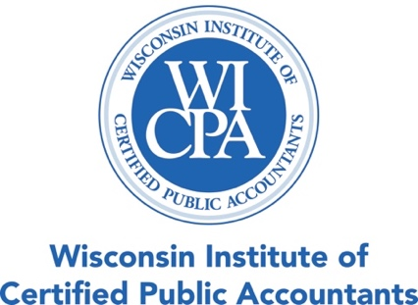

PLEASE SHARE THIS INFORMATION WITH ALL ACCOUNTING, BUSINESS AND
CAREER EXPLORATION EDUCATORS AT YOUR SCHOOL

Dear [Educator/Name of educator or contact person if known],

During the month of November, the Wisconsin Institute of CPAs (WICPA) and its members are celebrating Accounting Careers Month and launching an accounting awareness initiative where WICPA members, such as myself, are taking time to speak with high school classes about a career in accounting.

This initiative is specifically for educating Wisconsin high school students about the numerous career opportunities available to them and to get them excited about the accounting profession.

I would like to invite you to participate with me in this initiative this November! I will share my career path, the best parts of my job, the benefits of accounting as a career, and the variety of opportunities a career in accounting can provide.

I will also bring fun giveaway items and resources for the students.

Please email or call me with any questions and to schedule a date and time that works with your class(es).

I appreciate your time and look forward to hearing from you.

Thank you,

[Your Name]
WICPA Member
[Your Email Address]
[Your Phone Number]

